 | Biodata
Name | : | K.SANJEEVA REDDY
Qualification | : | M.Sc.,B.Ed,, APSET.
Designation | : | Lecturer in chemistry
Place of Work | : | Govt. Degree College
, |  | Jammalamadugu,

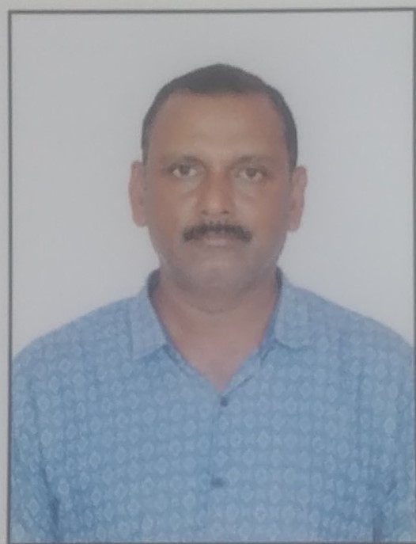
Date of Birth : 01-06-1972
Gender : Male
Marital status : Married Address : K.SANJEEVA REDDY
,JAMMALAMADUGU,YSRKADAPA DIST
e-mail: kcbr23@gmail.comil.com: cell:8897308827
BRIEF ACADEMIC PROFILE

Exam passed | Subjects offered | Institution where studied | University / Board | Year of passing | Grade &  %
APSET | CHEMISTRY | Osmania university  Hyderabad | Osmania university  Hyderabad | 2013 | -
M. Sc., | CHEMISTRY | Saifia college,  Bhopal | Barkatullah university  Bhopal | 2001 | 55.8%

DECLARATION: I affirm that information given in this application is true and correct, I also fully understand that if at any stage it is discovered that any attempt has been made by me to willfully conceal or misrepresent the facts, my candidature may summarily be rejected.
PLACE: Jammalamadugu
DATE: 23-01-2022 K.Sanjeeva Reddy

